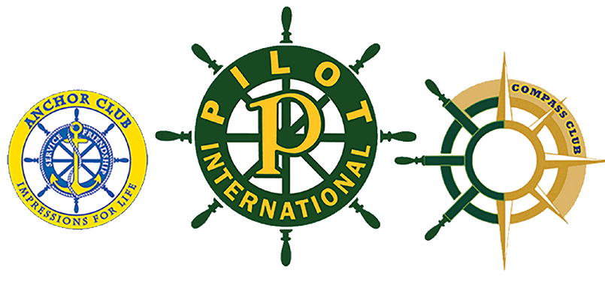
Alabama District Governor’s Bulletin
“The Power of Pilot”

2025-2026
District Administrative Council
Lisa Patterson, Governor
PC Prattville
28929 Canterbury Rd
Daphne, AL 36526
334.804.7201
lbpatterson72@gmail.com
Carolyn Williams, Gov-Elect
PC Huntsville
2610 Gawain Rd
Huntsville, AL 35803
256.880.0414
ecw720@comcast.net
Kay Chandler, Treasurer
PC Decatur
104 Jackson Way
Decatur, AL 35603
256.214.8551
misskay311@aol.com
Mary Ballard, Secretary
PLC of Morgan Co.
4020 Saddlehorn Bend SW Decatur, AL 35603
256.303.2465
alaiowa@yahoo.com

Stephanie Batton, ECR
351 Highlawn Drive
Ripley, WV 25271
304-531-1839
stephaniebatton@ymail.com

DECEMBER 2025 ISSUE 6

I hope that everyone had a wonderful Thanksgiving and isn’t too stuffed. For many of us this is a wonderful time with family. Christmas is just around the corner which brings such joy in our clubs and families holding annual parties, parades, and events.

The DAC members are completing club visits as we enjoy visiting with our Pilot friends across the great Alabama District. Each of us enjoys making new friends and reconnecting with those we know. We currently have 327 dues paying members and 23 non-dues paying for a grand total of 350 Pilots. Can we reach 375?
For our new members, “Welcome to Pilot”.

For your information, we also have 37 Compass members and 268 Anchors!

Fall Council was great, but it is now time to begin planning our 2026 Anchor and District Conventions. The first planning meetings are scheduled in January with the DAC and the DAAC.

Anchor Convention District Convention
March 7, 2026 April 24-26, 2026
Andalusia Chamber Embassy Suites & Conference Center
Andalusia, AL Montgomery, AL
Don’t forget about the 2026 TBI Camp. Treasurer Kay has discussed this in her article. Please be sure to read it.

2026 brings wonderful opportunities for Pilots. Please mark your calendars and plan to attend these conventions and the Alabama District Traumatic Brain Injury Camp, April 10-12, 2026 at Camp ASCCA where many more memories are created.

District Officer Qualification Forms are available on the Alabama District Website. We NEED NOMINEES for Governor-Elect, Lt. Governor, Treasurer and Secretary to serve along with 2026-2027 Governor Carolyn Williams. It’s never too early to start thinking about who to nominate for an officer. Please see Qualifications, let someone know you are interested, and if you have any questions please reach out to anyone on the DAC or Beverly Wilkerson, Nomination Committee Chair.
It’s hard to believe our 2025-2026 year is flying by so quickly. I am so grateful for all that each member within our clubs and communities does, not only during this Christmas season but, throughout the year. Each club across the Alabama District strives to provide valuable services to our communities through Pilot friendship.
May love and blessings find you throughout the holidays,

Lisa Patterson,
Governor

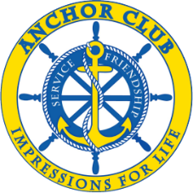
Anchor Convention-Go Make Waves

There is an inspirational message entitled, “Ripples” from the Healing Me(Me) Therapy. It says that:
“When you create a positive difference in someone’s life, you not only impact their life you impact everyone influenced by them, throughout their entire lifetime. Go make waves.”


I want to encourage you to have a positive impact on the lives of our Anchors by attending the Anchor Convention. Their one-day convention will be held in Andalusia at the Chamber of Commerce on March 7, 2026 from 9 AM – 5 PM. I feel that it is important for our Anchors to see Pilots as they come together to fulfill the guiding principles of the mission of Pilot International which is to influence positive change in our communities throughout the world.
Let’s Come and Make Waves with our Anchors,

Carolyn Williams,
Governor Elect
_______________________________________________________________________________

Secretary’s Report
Wishing each of my Pilot Sisters and Brothers a wonderful Christmas! As you prepare for your celebrations and traditions remember to be thankful for the good things that happen in your daily life. I am reminded every day that God woke me up because I am needed today. You are needed each day as well. While my skill set does not include cooking or crafting, I do enjoy listening to others and getting them to laugh. Playing games with children, singing silly songs, doing crafts with others and shopping for Bingo prizes are some of my favorite things. Whatever your skill set is please know that it is needed to brighten the day of someone else. Isn’t that why you became a Pilot in the first place? I hope so. I hope that you will end this year knowing that you are needed each day and that whatever your joys in life are you will use them to be of assistance to others.

P.I.F.F Notice
Pick Me Up Grant applications due to PI on or before December 15, 2025
Helmet Grant applications due to PI on or before December 15, 2025
250 Club and Pacesetter Contributions due February. 7, 2026
Mary Ballard,
District Secretary & Pilot International Founders Fund
_______________________________________________________________________________

Treasurer’s Message
Thanksgiving 2025 has come and gone. Christmas is on the horizon. Then it’s Happy New Year and time to get busy with our 2026 Traumatic Brain Injury Camp.

I will be posting registration for all our Campers/Caregivers very soon. They are already calling to get registered. Great news!!! We received our $5,000.00 Matching Grant from Pilot International Founders Fund. A great big shoutout and thank you to PIFF. That’s our Alabama’s donation coming right back to Alabama!!

Now we must do our part, match the $5,000!!!! We need 25 Camperships! Camperships are still $300 each. If you have a Camper/caregiver you want to sponsor with your Campership, that’s great!! But, if you just want to donate a campership, we’ve got lots of Campers/caregivers that need a sponsor. Why not follow Andalusia’s lead and get us a Corporate Sponsor??? Benny Jo Cockrell is working on securing a grant from the state. We are a 501(c)(3), so all donations are tax deductible.

Get the date on your calendar, April 10-12, 2026. Get your favorite team’s baseball cap and let’s go to Camp ASCCA and celebrate Pilot, Anchor, and Compass with all our Campers!

Fall Council 2025 is in the books. We were in the red, but not as bad as we thought we would be. Thank you to all who purchased box lunch. This saved us! We met our food minimum. Sometimes we have to think outside the “box”.

District Convention is coming soon, and we need every club there! We have a sleeping rooms commitment, and we must fill them up with Pilots! We also have food minimums too, so it’s come eat, come stay and come be an Alabama Pilot. The dates are April 24-25-26, 2026. Plans are in the “planning” stage and it’s going to be exciting, fun and informative. April is going to be a great month for our Alabama District Pilots.

Merry Christmas to all and wishing you a wonderful, happy, New Year. If you see Santa, send him north!



Kay Chandler,
District Treasurer

________________________________________________________________________________
Pilot Cares, Concerns and Celebrations

Christmas Blessings

“When the song of the angel is still,
When the star in the sky is gone,
When the kings and princes are home,
When the shepherds are back with their sheep,
The work of Christmas begins
To find the lost, to heal the broken, to feed the hungry,
To release the prisoner, to rebuild the nations,
To bring peace among people, to make music in the heart.”
Howard Thurman

*****************************************************************************
Pilot Cares, Concerns, and Celebrations
The following Pilots are in our thoughts and prayers:
PC of Andalusia:
Mollie Riley will be having robotic knee replacement this month. Cards and prayers for successful surgery may be sent to 300 Sheraton Drive, Andalusia, AL 36420.

PC of Gadsden:
Emeritus Member, Alma Alford, passed away in November. Several former members attended her services. Our deepest sympathy to her family.

PC of Lee County:
Fay McCrary had a hard fall at home and injured both shoulders. Caring cards may be sent to
4008 Stratford Way, Opelika, AL 36801.

Nancy Barron is mourning the passing of her mother, Sarah Barron, Our deepest sympathy to all family members. Condolences to Nancy may be sent to 775 Lee Road 47, Opelika, AL 36804.

PC Prattville:
Alabama District Governor, Lisa Patterson, is facing upcoming robotic total-knee replacement surgery. We hope Lisa will feel the love and prayers coming her way for successful surgery and recovery.
Cards may be sent to 28928 Canterbury Road, Daphne, AL 36526.

PI Member:
Past District Governor, Cookie Adair, is recovering from knee replacement surgery. She is healing and will be out and about soon. Cards may be sent to 534 Howell Cove Road, Talladega, AL 35160.

In Pilot friendship and Service,

Sherre

Sherre McGinnis
sam109@bellsouth.net
256-490-7271

“May grace and peace be yours in abundance” 2 Peter 1:2
______________________________________________________________________________


Executive Committee Representative

Best wishes and season’s greetings for the holiday season from your Pilot International Executive Committee. May this season bring you love, good health, and peace.
Our Giving Tuesday campaign is December 2, and you can still donate past that date to benefit our Youth Programs and Operations. Our goal is set at $20,000 and your generosity is amazing! Stay tuned for the total raised!!
December 1 is the deadline for our Governor-Elects to send to Pilot Headquarters (clubservices@pilothq.org) the names of their Coordinators and Appointees as well as dates and locations for their Fall Council/Workshop and District Convention.
Heritage Brick Orders are due December 15, and this is a fabulous way to honor Pilots, clubs, and Districts. These bricks are placed in the Heritage Garden at Pilot International Headquarters. If requested, an acknowledgement letter is sent to the honoree acknowledged.

PMU and Helmet grant applications are due December 15. Please consider applying for these grants to benefit your communities.
Pilot Headquarters is closed December 24 and 25 so the staff can spend time with family and friends.

May the Spirit of the Holidays be with you throughout the
New Year!

Stephanie Batton
Executive Committee Representative


_______________________________________________________________________________
Anchor

The 2026 Anchor Convention will be held on March 7, 2026, at the Andalusia Area Chamber of Commerce. Registration will be $25 per person. Registration form coming soon.

We have an etiquette lesson tea party planned, and for our District Service Project, we will be packing food items for Full Tummy of Covington County. Make plans to join us for a fun and meaningful day of learning, service, and fellowship!

For those needing overnight accommodations, rooms are available at the Holiday Inn Express in Andalusia.

Reminder Alabama District Anchor Officer Nominations by January 6, 2026, and Anchor Award Forms are due by February 5, 2026 forms are available at www.alabamadistrictpilot.com.
Mellisa King
Alabama District Anchor Coordinator

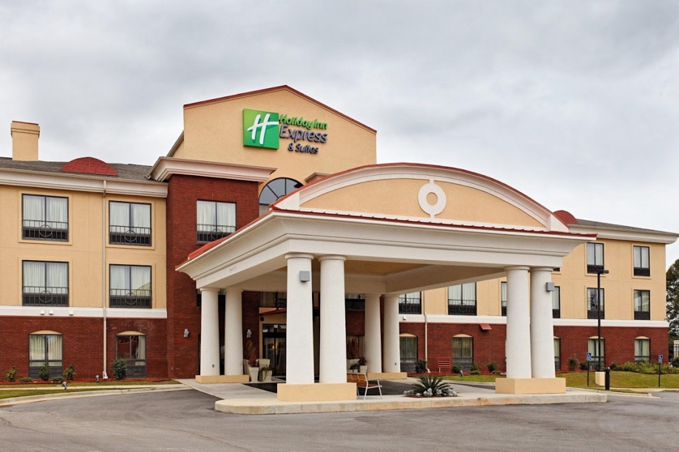
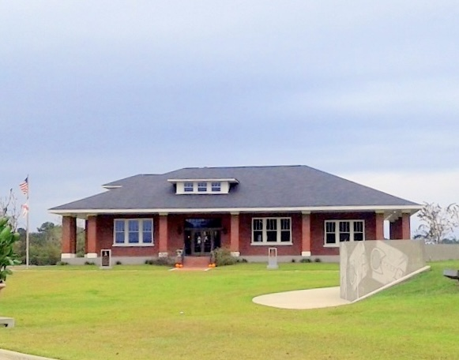
Andalusia Chamber of Commerce Andalusia Holiday Inn Express
700 River Falls St. 16727 US Highway 84
Andalusia, AL 36420 Andalusia, AL 36421

You are Welcome to Join Us!

________________________________________________________________________________

