__________________, 2022
[Date]

City, State – The Pilot Club of _____________ Encourages Locals to “Get Real” during International Care & Kindness Week, November 7 – 13, 2022.
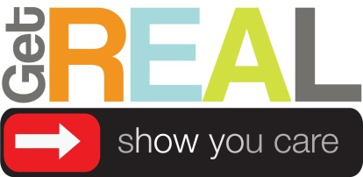
In partnership with [local restaurants/businesses where your club has placed “Get Real” campaign materials], The Pilot Club of ___________ encourages families to “Get Real” at mealtimes by putting down electronic devices – both at home and out to eat during International Care & Kindness Week, November 7-13, 2022.
Look for specially marked baskets or laminated place cards in participating restaurants and businesses. Pilot’s “Get Real – Show You Care” campaign asks families to put down their virtual toys and engage in REAL conversation. Through the “Get Real” campaign and other International Care & Kindness Week initiatives, The Pilot Club of _____________ spreads the news that caring for one another means really engaging with one another. Put down your phone, and pick up someone's hand.
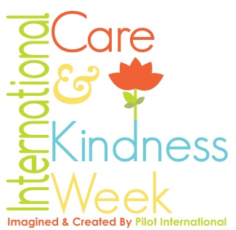
Pilot International created and supports International Care & Kindness Week - the second week November – to bring awareness to how simple acts can change a day, a life, or the world by simply showing someone you care.
Now in its 101th year, Pilot International is a volunteer service organization with over 500 clubs throughout the world. Committed to“Do More. Care More. and Be More” for their communities every day, Pilots, Anchors and Compass members provide financial and hands-on support for numerous national and local initiatives in keeping with Pilot International’s focuses – Brain Safety & Health and Supporting those who care for others.
For more information about Get Real, International Care & Kindness Week and Pilot International, please contact:
[Include Your Contact Information Here]
###

