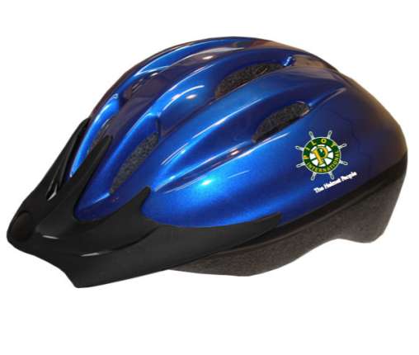Pilot International Helmet

Matching Grant Application

Grant applications will be reviewed quarterly by the Helmet Matching Grant Committee.

The deadlines for each quarter are on or before:

* September 15th
* December 15th
* March 15th
* June 15th

**Pilot, Compass & Anchor clubs or districts are eligible to receive one (1)**

**Helmet Matching Grant per calendar year.**

**Completed applications are to be sent to:**[**helmets@pilothq.org**](mailto:helmets@pilothq.org)

**Subject line to read: Helmet Matching Grant Submission**

NOTE: If grant request application does not meet criteria in one quarter, the submitting club may reapply in a future quarter.

Helmet Matching grants are to be used to fund the purchase of Pilot International branded helmets. Helmets are not to be used for resale. Grants will not be awarded to clubs for a helmet event scheduled within 60 days of submission date to allow proper shipping time.

Matching Grant will award $300 for the purchase of 25 helmets. Clubs will be responsible for purchasing 25 additional helmets for a total of 50 to complete the matching grant criteria. Any additional helmets needed may be purchased in same transaction.

Grant applications should be emailed by the deadline to Pilot International Headquarters. (Electronic signatures are acceptable and encouraged.) If mailing, please mark your envelope: “Helmet Matching Grant Submission”. Allow time for PIHQ to receive the grant prior to the submission date.

Mission: The Helmet Matching Grant Program will provide clubs the opportunity to participate in this Signature Project by ordering quality, branded bicycle helmets that will start individuals on a positive path of protecting their brains for life while promoting Pilot International.

Pilot International Helmet Matching Grant Application

Date of Application _________________________

Club Name: ________________________________District: ________________________

Contact Name: ____________________________________________________________

Address: _________________________________________________________________

Phone: _______________________ Email: _____________________________________

Descriptive Title of Helmet Event:_____________________________________________

Estimated date of Helmet Event: _______________________________________________

*Estimated date must be at least 60 days after the deadline submission date.*

Estimated number of members participating_________ Total % of Club Members ___________

How many individuals will receive a helmet? ________________________________________

**On separate sheet of paper please provide the following:**

1. What is the Helmet project/event and how does it relate to the Signature Project goal?

2. Describe the individuals to receive the helmets.

3. Describe the benefit to the club by participating in this event.

4. Attach an estimated itemized budget for the event.

5. Include a Press Release for event/project with email list of media outlets.

**IMPORTANT: Follow-Up Requirement**

If the Helmet Matching grant is awarded to your Club; you are required to submit the following to Pilot International within 30 days of the event. Failure to submit this information may require you to forfeit the grant funds and repay them. It may also disqualify you from applying for any future Helmet Grants. No other request for this information will be sent, so please keep a copy of this application in your files.

Up to thirty (30) days after your Helmet event, please submit the following to PI Headquarters:

1. A description of the event, including who was present, date and time.

2. Any written or verbal responses from the recipient(s) and their names.

3. Copies of Photos & Media Coverage taken at the helmet event if possible.

4. Press release emailed to media with Pilot International copied to [**lia@pilothq.org**](mailto:lia@pilothq.org)or [**helmets@pilothq.org**](mailto:helmets@pilothq.org)

_____________________________ ______________________________

Club President’s Printed Name Club Treasurer’s Printed Name

_____________________________ ______________________________

Club President’s Signature Club Treasurer’s Signature

Date received at Pilot International: _____________

THANK YOU FOR YOUR PILOT SERVICE!

Pilot International Helmet Matching Grant Scoring Criteria

|  |  |
| --- | --- |
| # Points | Scoring Criteria |
| 5 pts | Event/Project promotes Pilot International’s mission. |
| 5 pts | Club benefit, visibility, partnership, community outreach etc.… |
| 5pts | Brainminders Presentation was presented at event. |
| 5pts | Helmet Fittings by Pilots at event. |
| 5 or DQ | If itemized budget not included, request is disqualified. |
| 5 or DQ | If Press Release is not included, request is disqualified. |
| 1pt Bonus | First time helmets have been provided by club. |
|  | . |
|  | Total points possible 31. Grants are reviewed by the Helmet Grants Committee |

**SAMPLE PRESS RELEASE**

**HELMET MATCHING GRANT**

**The Pilot Club of __________________ Receives a Helmet Matching Grant**

**from Pilot International**

The Pilot Club of ______________ received a Helmet Matching Grant from Pilot International for a project entitled, “__________________.” Through this grant, the Pilot Club of ________ received 25 high quality helmets to combine with the helmets they purchased.

Approximately 40% of all bicycle-related deaths are due to head injuries; ¾ of all bicycle-related head injuries occur among children ages 14 and under; and many children are simply unable to protect their heads while bike riding because they don’t have access to quality, affordable safety helmets. This international signature project allows Pilots, “The Helmet People,” to place safety helmets on the heads of as many youths as possible.

Because of this grant, members of the Pilot Club of ____________ were able to visit children at ______(LOCATION)_______ in ____(CITY)______ . Pilots presented a BrainMindersTM puppet show to teach the children how to protect their brain for life. ____(# of)___ helmets were presented to children and Pilots assisted with proper fitting of the helmets for each child. Children were also given BrainMindersTM coloring books to reinforce good safety habits at school and home.

For more information about the Pilot Club of ___________, please visit our club’s website at _____________; or contact our President, ______________, at _____________. We are currently seeking new members who wish to join a great organization of friendship and service to make an impact not only in their local community, but also in the world. Also, please visit our international website at [www.pilotinternational.org](http://www.pilotinternational.org).

(Photos will accompany this press release.)

Email list of media outlets:

(local newspapers)

(local television station)

helmets@pilothq.org

as well as the Pilot Club of __________ Facebook Page and [Pilot International’s Facebook page](https://www.facebook.com/pilotinternationalheadquarters)